**Final Project Proposal**

**Bee Informed!**

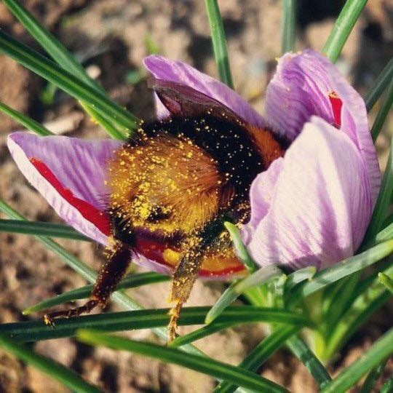

We collected data on honeybee colonies from the USDA Economics, Statistics and Market Information System website at <https://usda.library.cornell.edu/concern/publications/rn301137d?locale=en>. Our goal is to visualize trends in honeybee colony collapse and the stressors on bee colonies, from January 2015 through June 2018. We plan to clean our data with Pandas and Numpy, use Tableau to show our visualizations, and use Matplotlib and Sci-Kit Learn for machine learning to predict future colony populations.

Camilla Bahr

Subhra Nandi

Sarah Sprole